VIP Syllabus • Spring 2023
Vertically Integrated Projects Program • vip.gatech.edu

Each team will determine working times, designated as “sub-team meetings.” Students are responsible for participating in their team and sub-team meetings. If you miss any meeting, you are responsible for knowing what occurred in that meeting (typically by discussing it with other team members). An excused absence does not relieve you of that responsibility. | About VIP  The Vertically-Integrated Projects (VIP) Program operates in a research and development context. Undergraduate students that join VIP teams earn academic credit for their participation in design/discovery efforts that assist faculty and graduate students with research and development issues in their areas of expertise.  The teams are:  Multidisciplinary - drawing students from all disciplines on campus;  Vertically-integrated - maintaining a mix of sophomores through PhD students each semester;  Long-term - each undergraduate student may participate in a project for up to three years and each graduate student may participate for the duration of their graduate career.  The continuity, technical depth, and disciplinary breadth of these teams are intended to:  - Provide the time and context necessary for students to learn and practice many different professional skills, make substantial technical contributions to the project, and experience many different roles on a large, multidisciplinary design/discovery team.  - Support long-term interaction between the graduate and undergraduate students on the team. The graduate students mentor the undergraduates as they work on the design/discovery projects embedded in the graduate students' research.  - Enable the completion of large-scale design/discovery projects that are of significant benefit to faculty members' research programs.

Semester Overview
Week | Date | Activity/Event
Week 1 | Week of Jan 9 | Introductions.  Overview of teams’ work.  Discussion of semester goals.
Week 2 | Week of Jan 16 | Sub-team selections finalized.  Sub-team meeting times finalized.
Week 7 | Monday, Feb 20 | Midterm grades for 2000-level courses due in OSCAR (S for satisfactory, U for unsatisfactory).
Week 7 | Week of Feb 20 | Web-based peer-reviews released for students to complete. Online form due at 4PM Friday.  Turn design notebooks in at team meeting for mid-term grading.
Dead Week | Apr 17 – Apr 28  Open Close | Final presentations.  Web-based peer-reviews released for students to complete. Online form due at 4PM on Tuesday.  Design notebooks collected for final grading at time of final presentations.
Finals Week | Apr 27 – May 4 | No final. No assignments.

Grading
The premise of VIP is teams working on projects. Much like a real-world engineering team, individual members work on different aspects of the project. Team members range from sophomores through graduate students, from first-time participants to students who have been involved for four or more semesters. Some students take the course for one credit, and others take it for two credits.

Your grade is based on three areas, along with three requirements. Although each student may work on different areas and contribute differently, you must show achievements in all three areas below.

**Follow up with instructor for more details**

- Documentation and records (33%)
- Design Notebook
- Wiki/blog documentation if used by team
- Code (via SVN) if used by team

- Personal accomplishments and contributions to your team’s goals (33%)
  - Quizzes, learning modules, essays, reports required by your adviser(s);
  - Engagement in project;
  - Pursuit of knowledge necessary for project;
  - Contributions to the technical progress of the team;
  - For more experienced members of the team, contributions to the management of the project may be expected.

- Teamwork and interaction (33%)
- On-time attendance in meetings
- Actively contributes to overall team goals
- Coordinates activities with other team members
- Assists other team members
- Team Presentation(s)
- Peer Evaluations

- As part of the assessment of the above, each student is required to:
- Maintain a design notebook. Example design notebooks are available at: https://vip.gatech.edu/vip-notebooks
- Complete the mid-term peer evaluation. This is a web-based form, and links are available at http://vip.gatech.edu. Failure to complete the peer evaluation will result in a full letter grade deduction. Late submissions are not accepted.
- Complete the final peer evaluation, which will be available for one week during Dead Week. Failure to complete the peer evaluation will result in a full letter grade deduction. Late submissions are not accepted.

Performance Assessments

Performance assessment will be done once at mid-terms and again at the completion of the semester. The mid-term assessment is advisory. | 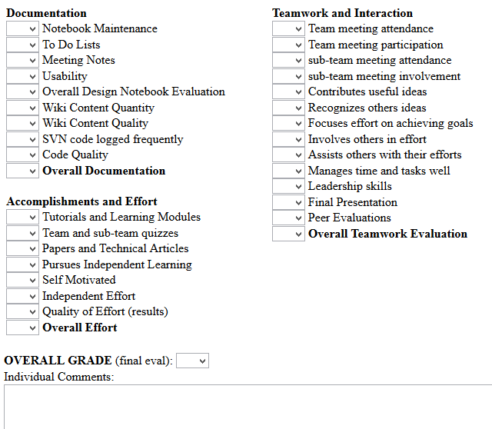

Notes on Documentation
Notebook Maintenance | - The notebook does not have removable pages.  - Your name, your project's name, your contact info and your team members' contact info are recorded on the cover or inside of the cover.  - Each page is numbered, dated and signed.
To-Do List Maintenance | - Maintain check-boxes for items to be done that are then checked-  off and dated when done.
Meeting Notes | - Detailed meeting notes that include check-boxes for items for  which you are responsible and deadlines for your sub team and  the overall team.
Usability | - Will your design notebook be of use to people who join the team  later and need to refer to it? This includes legibility, intelligible  technical and meeting notes, and overall organization.
Overall | - An overall rating of your notebook. (Detailed design notes, design  decisions, copies of or pointers to code that you wrote, records of  important websites, etc.)
Wiki content | - Wiki content refers to documentation produced online, either  through the VIP wiki site, T-square, or other team-approved site.
SVN code | - SVN code refers to code produced and checked into the VIP SVN  site or other team-approved site. The frequency, quantity and  quality of contributions are evaluated.

Academic Honesty
The main principle in VIP academic honesty is that you will not present someone else’s work as your own. Tests and specific assignments (homework, lab assignments, etc.) must be your own work. For other work you are encourage to consult whatever sources are helpful in learning and understanding the issues associated with the material, but you should always provide appropriate references and citations where such material is included in your design notebook, programming code, presentations, etc.

Additionally, to provide a good working environment for all students, you’re expected to adhere to rules given here, posted, or disseminated in class. Academic Honesty is taken seriously and failure to follow these principles will result in disciplinary actions as given in the Student/Faculty Handbook.

Accommodations for Students with Disabilities
Georgia Tech offers accommodations to students with disabilities. If you need a classroom accommodation, please make an appointment with the Office of Disability Services (www.disabilityservices.gatech.edu/). If you have an accommodation letter from the Office of Disability Services and require accommodations, please see your team’s advisor.

Labs and Facilities
VIP has rooms and equipment that are shared by many VIP teams. In order to provide a good working environment, the following rules apply to anyone with access to these rooms and equipment:

- The room priorities are:
  - Scheduled team meetings, lectures and learning modules
http://vip.gatech.edu/new/classroom-schedules
  - Video conferences
http://vip.gatech.edu/new/classroom-schedules
  - Weekly sub-team meetings (multiple groups can use rooms at same time)
  - Other project-related work (multiple groups can use rooms at same time)

While these priorities indicate which events take precedence, a good neighbor policy on using the rooms applies. If you need to access computers, equipment, or work on project work in the room while other activities are going on (sub-team meetings, etc.), you are welcome to do so as long as it does not disrupt a scheduled activity. Similarly, multiple groups may use a VIP room at the same time. Also, where it does not disrupt one of the above uses, VIP participants may use the rooms for other activities such as studying.
- Everyone is expected to pitch in to keep the rooms clean. Faculty/team advisors do not appreciate having to clean up after students. Food is allowed in the rooms provided any spills or messes created are cleaned up. Gum is a particular problem especially in carpeted rooms. Do not place used gum anyplace other than wrapped in a trash can!
- The rooms have equipment both for general use and for specific teams. General use equipment includes the projector in Klaus 1440, and the display in VL 465. Other equipment may be for general use or dedicated to a team specific purpose (some equipment may be general use one semester and assigned to a team another semester). You should not use team-specific equipment except for the designated purpose. If you are uncertain whether the equipment is available for general use then you need to determine that it is available and appropriate for you to use before using the equipment. Some equipment may pose hazards if used inappropriately!
  - Equipment may not be removed from a VIP room without filling out a written record approved by the appropriate team advisor.
  - You will be responsible for the replacement cost of any equipment not returned in good condition.
  - You must be sure you know how to operate the equipment safely. Written approval to use the equipment does not indicate that the team advisor has reviewed equipment use and safety. You are responsible for knowing the hazards and safe operation of any equipment you use.

- Computer accounts are issued for your use only. You may not share computer accounts with anyone else, even another team member. All computer usage is subject to rules and policies of Georgia Tech, the University System of Georgia Board of Regents, and the State of Georgia. Additionally, you are expected to be considerate of other users. Computer permissions are not authoritative. For example, just because you have file access to something does not indicate that it is appropriate for you to read or modify that file.
- Buzz-card access to VIP facilities is a privilege contingent on abiding by the above rules. Buzz-card access is logged, and rooms are video recorded. Be aware that if there is a problem (theft, vandalism, or simply a mess left in a room), the logs and video records will be consulted. Do not allow unknown people to access VIP facilities. Be sure to secure the facilities (i.e., close the door) when you leave.

